ELECTRIC CIRCUITS

HOMEWORK

Due Date 01/12/2014 (H-16:00)

1. Two electric circuits, represented by boxes A and B, are connected as shown in Figure.The reference direction for the current i in the interconnection and the reference polarity for the voltage v across the interconnection are as shown in the figure. For each of the following sets of numerical values, calculate the power in the interconnection and state whether the power is flowing from A to B or vice versa.

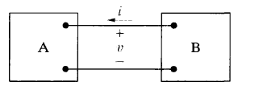a) i = 10 A, v = 125 V

b) / = 5 A, v = -240 V

c) i = -12 A, v = 480 V

d) / = -25 A, v = -660 V

1. 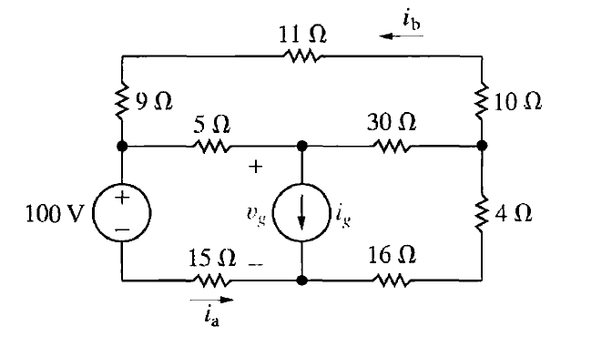The currents ia and ib in the circuit in Figure are 4 A and —2 A, respectively.

a) Find ig,

b) Find the power dissipated in each resistor.

c) Find Vg.

d) Show that the power delivered by the current source is equal to the power absorbed by all the other elements.

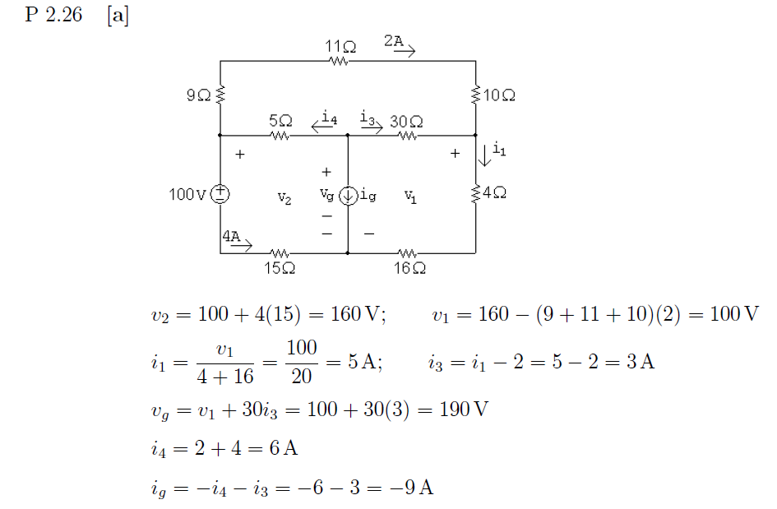

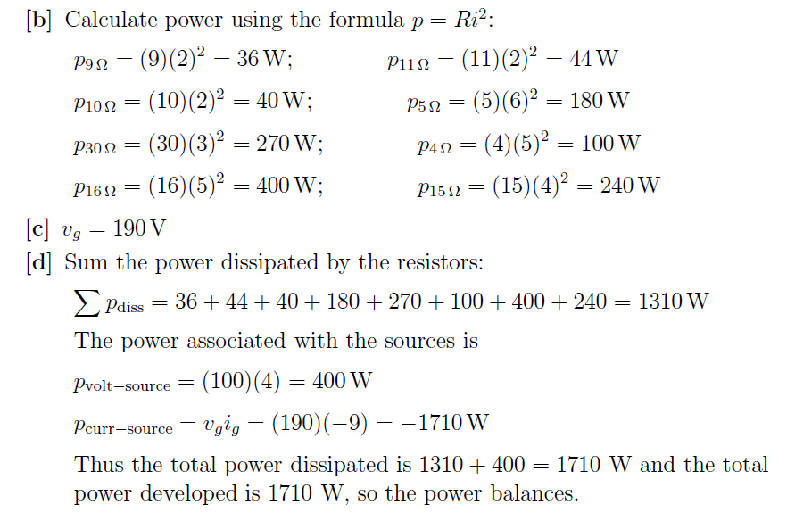

1. For the circuit shown in Figure, calculate
   1. *i∆* and *V0* and
   2. show that the power developed equals the power absorbed.

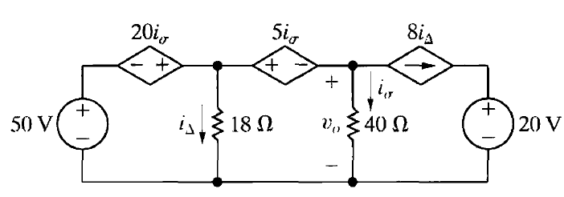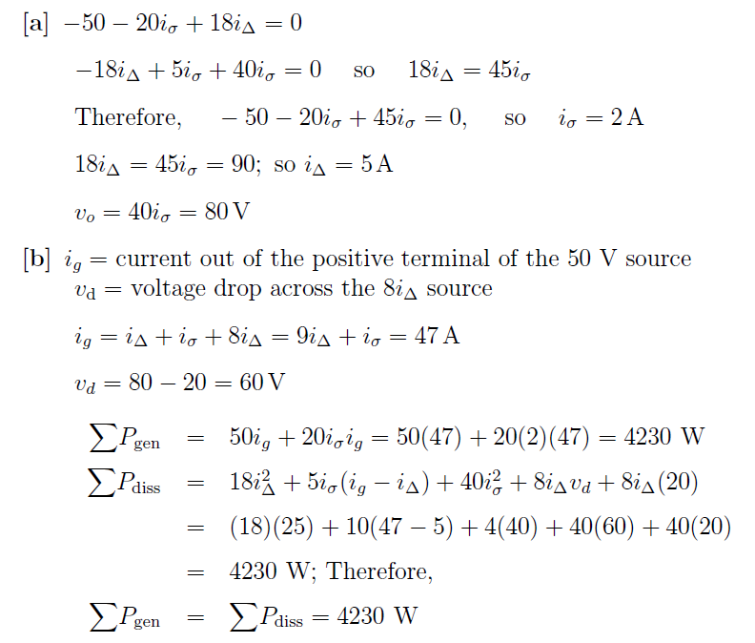

1. 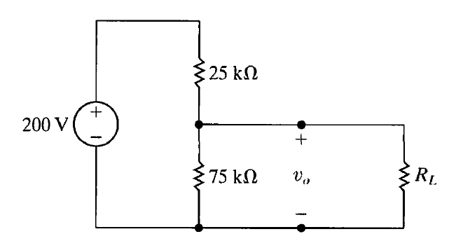

a) Find the no-load value of v0 in the circuit shown.

b) Find v0 when RL is 150 kΩ

c) How much power is dissipated in the 25 kΩ resistor if the load terminals are accidentally short-circuited?

d) What is the maximum power dissipated in the 75 kΩ resistor

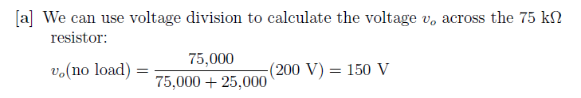

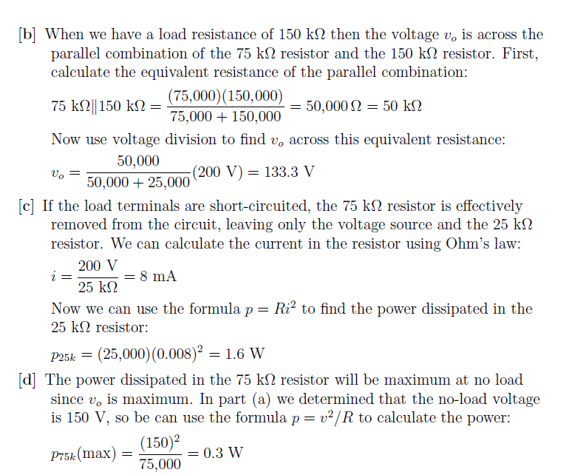

1. a) For the circuit in Figure, find the equivalent resistance Rab,

b) For each circuit find the power delivered by the source.

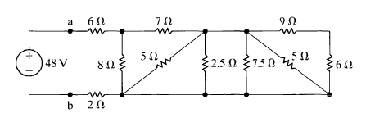

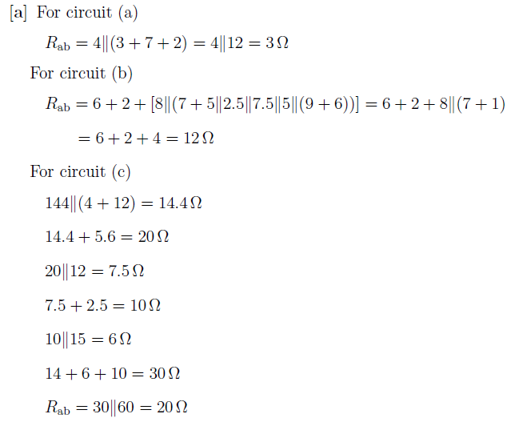

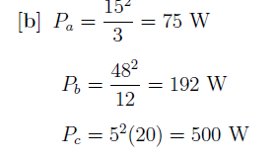

1. For the circuit in Figure, find *V0*.

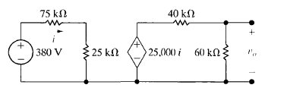

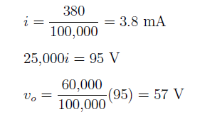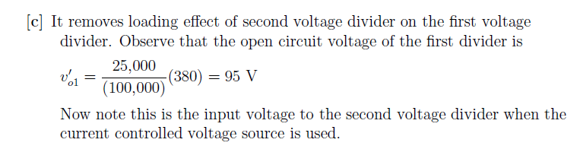

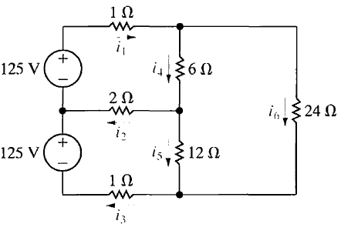For the circuit shown in Figure ,

a) Use the node-voltage method to find the branch currents *i1 - i6.*

b) Test your solution for the branch currents by showing that the total power dissipated equals the total power developed.

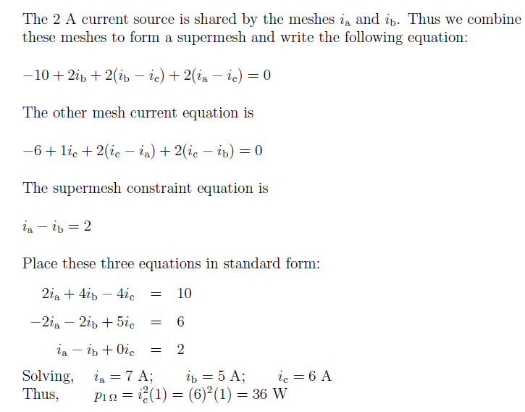

8. a) Find the node voltages *V1,V2* and *V3* in the circuit in the Figure.

b) Find the total power dissipated in the circuit.

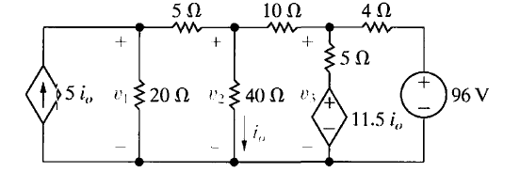

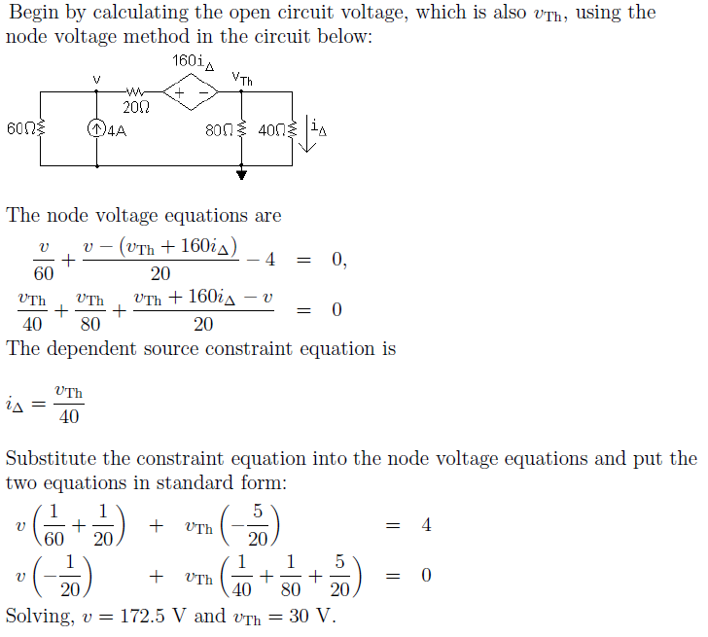

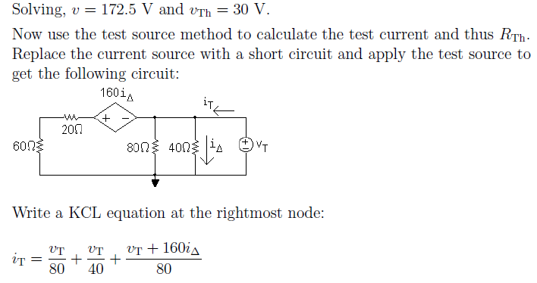

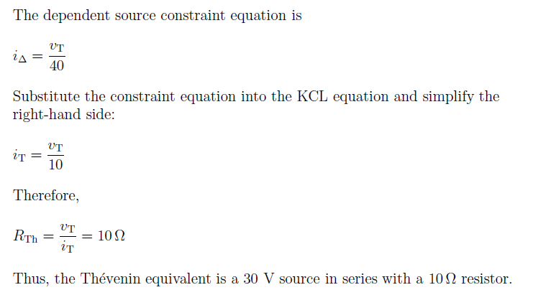

9. Use the mesh-current method to find the power dissipated in the 20 Ω resistor in the circuit below.

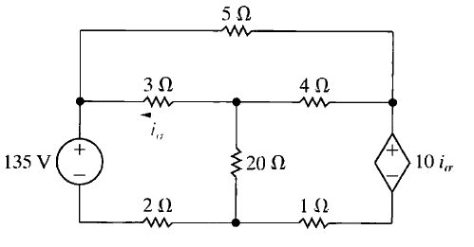

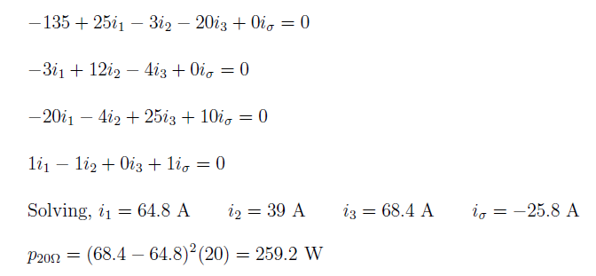

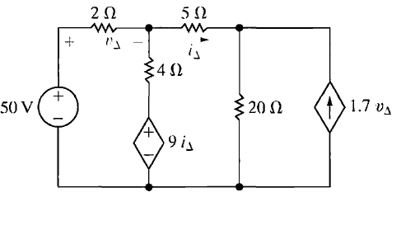10.

a) Use the mesh-current method to determine which sources in the circuit in Figure are generating power.

b) Find the total power dissipated in the circuit.

